|  |  |  |  |  |
| --- | --- | --- | --- | --- |
|  |  | | | |
|  | |  | | |
| Project: | | University Food System (UFS) | | |
| Team No.: | | Team 3 | | |
| Class: | | CSE 3310; Fall 2021 | | |
| Module: | | System Requirements Analysis (SRA) | | |
| Deliverable: | | SRA Document | | |
| Version: | | [1.0] | Date: | [10/28/2021] |

Contributors:

Cameron Chilcoat

Ja’Lun Morris

Sumaita Sabaha

Gia Dao

Revision History

| Version number | Date | Originator | Reason for change | High level description of changes |
| --- | --- | --- | --- | --- |
| 1.0 | 10/28/2021 | Team# | Initial draft |  |
|  |  |  |  |  |
|  |  |  |  |  |
|  |  |  |  |  |

TABLE OF CONTENTS

1. Introduction and Project Overview 3

2. Objectives 4

2.1 BUSINESS Objectives 4

2.2 SYSTEM Objectives 5

3. Project Context Diagram 7

4. Systems Requirements 8

4.1 “Registration And Login” Requirements 8

4.2 “Search” Requirements 11

4.3 “Payments” Requirements 12

4.4 “Orders” Requirements 13

4.5 “Restaurants” Requirements 14

4.6 “Advertisement” Requirements 17

4.7 “Delivery” Requirements 18

4.8 “Communication” Requirements 19

4.9 “Rating” Requirements 20

5. Software Processes and Infrastructure 22

5.1 Hardware and Infrastructure 22

5.2 UML Diagrams 22

5.3 Screen Shots 32

5.4 Test Plan 32

6. Assumptions and Constraints 33

6.1 ASSUMPTIONS 33

6.2 CONSTRAINTS 33

6.3 Out of Scope material 33

7. Delivery and Schedule 34

8. Stakeholder Approval Form 36

Appendix: 37

# Introduction and Project Overview

Develop an android application to help university students order food and provide information about on-campus and near-campus restaurants and food providers (e.g., restaurant review and comments). The system should have an appealing home screen and minimally include the following functionality (you may modify or add additional functionality after receiving approval from your client):

* Registration: Students must register before they can use the system. University ID can be used as member Id.
* Login: Members must login to use the system after initial registration.
* Payments: System should be able to handle payments (Meal plan and Credit cards only; You do not need to validate credit cards for this project, just make them 16 digits long, have an expiration date, and a 3-digit security code)
* Restaurants: System should allow vendors to add their restaurants and their menu (e.g., subway, Panda express, connection café and other on campus restaurants).
* Orders: Place food order (e.g., Sandwich and coke with chips etc.). System should also allow for modifying your order after the initial placement within 5 minutes of your initial order time (i.e., cancel an order to modify existing order by adding new items).
* Communication: System should allow for sending text messages/e-mails to a single, subgroup or all members (e.g., Your order has been placed, your order is on its way etc.)
* Delivery: System should allow students to track their order and get their food delivered or select an option for pick up.
* Favorites list: Allow creating a favorite list of restaurants (you must have ordered at least once from a restaurant before you can add it to your favorite’s list)
* Search: You should be able to search for different food items or restaurants
* Review and Rating: Use Stars (one to five stars) to rate the service received, and allow to enter for a short comment to help future users
* Advertisements: System should provide advertising space (e.g. Local subway store offers specials or coupons to members). This could be a source of revenue from the app.
* {**for Honors Credit only**}
  + Create a map displaying your location and the resultants.
  + Include an accurate time estimation of the project. Prepare a 6-page report (single-space, font 11 or 12) using “Softstar Systems – COCOMO estimation” at: <http://www.softstarsystems.com/demo.htm>

# 2. Objectives

## 2.1 BUSINESS Objectives

The following is a list of business objectives:

**Objective 1**: Login/Registration: All members must provide the following information prior to using the system:

If the user is not registered, then he/she needs to provide the following information

* Name {First, Last name}
* Email address
* Phone number
* Select an ID {at least 8 character long, alphanumeric, wild characters not allowed}
* Select a password {Must include, letters, at least one number, at least Capital letter, wild characters allowed)
* Select a security question/answer (to be Used for password forgot/reset)

If the user already registered, he/she can type in the user ID and password and press the button to log in.

If the user forgets the password, ask user for the Answer to the “Security Question” entered during the “Registration” phase. Also ask for e-mail address. If both e-mail and security answer is correct, reset the password and e-mail the temporary password via e-mail

**Objective 2**: Search: System should be able to allow user to use the search bar, which will display the suggested restaurants according to the result of the search

To search for a specific location within the university area, user must provide either:

* Name of the restaurant
* Location of the restaurant

After search and suggestions are shown in the drop-down menu, user can press on the restaurant to navigate to the restaurant’s main page. If the restaurant is not available, the system should notify the user with error message, and ask if the user want to select a different location.

**Objective 3**: Payments: System should be able to handle payments (Meal plan and Credit cards only)

Display two options of payment on the screen for the user to choose from: Credit cards or Meal Plan

If the user selected ‘credit card’:

* If the user is not registered this method, they must provide the following information:
* Name {First, Last name}
* Address
* Email
* Phone number
* 16-digit card number an ID {at least 8 character long, alphanumeric, wild characters not allowed}
* CVV number
* Expiration date

**Objective 4**: Order: System would allow user to make an order (or select items) from a specific restaurant:

Display menu that contains the pictures of the items and their prices according to the chosen restaurant. The system allows the user to add the items to their cart by clicking on the icon or remove items from their cart. The user can also view the sub total of their order every time they access their cart.

The user can press the buttons:

* Add Button to add the items
* Remove Button to remove the items
* Cancel Button to discard the order

**Objective 5**: Restaurant: Each restaurant will have the following information

* Name
* Location
* Cuisine
* Hours
* A Menu
* Current backup time

In the app there will be a screen to view the restaurant’s menu when placing an order. An administrator side to the system will update restaurant and menu qualities. The server side will maintain a list of restaurants and its qualities.

**Objective 6**: Advertisement: Each restaurant will be able to create an advertisement that can be clicked to view the order placing menu screen. An advertisement includes the following.

* Image file
* Text
* Font
* Background color
* Restaurant

**Objective 7:** Delivery: The system should let the customer choose between pick and delivery:

The system should display two buttons for user to choose: Delivery and Pick Up

Customer chooses pickup, customer will get alert when order is ready

If the customer picks delivery:

* The system will notify the shipper’s information, including vehicle types, color, …
* Calculated the estimated time before reaching the user’s location
* Display successful delivery message if the user received their items
* At the same time, the user will be able to track their order using map displayed on the screen

**Objective 8:** Communication: System should allow the user to send messages/e-mails to the administrators

If the user has any complaint, they can directly contact the phone or email address that’s attached below the selected restaurant. The system will then notify the user it has received the feedback and recommend the user to wait for response.

**Objective 9:** Ratings: Each order completed will be able to be reviewed by the placing customer. A rating will include the following:

* Number of stars
* Reason
* Month of order
* Year of order
* Reviewed

Ratings are maintained and stored via a ratings list for each restaurant. Reviewed ratings are displayed in app.

## 2.2 SYSTEM Objectives

The following is a list of system objectives:

**Objective 1**: System will be an Android application version 2020.3.1 Bumblebee

**Objective 2**: Search functionality will utilize Google’s search

**Objective 3:** Firebase will be used to save limited amount of data (stored the user’s information, such as name, phone number, email…)

# 3. Project Context Diagram

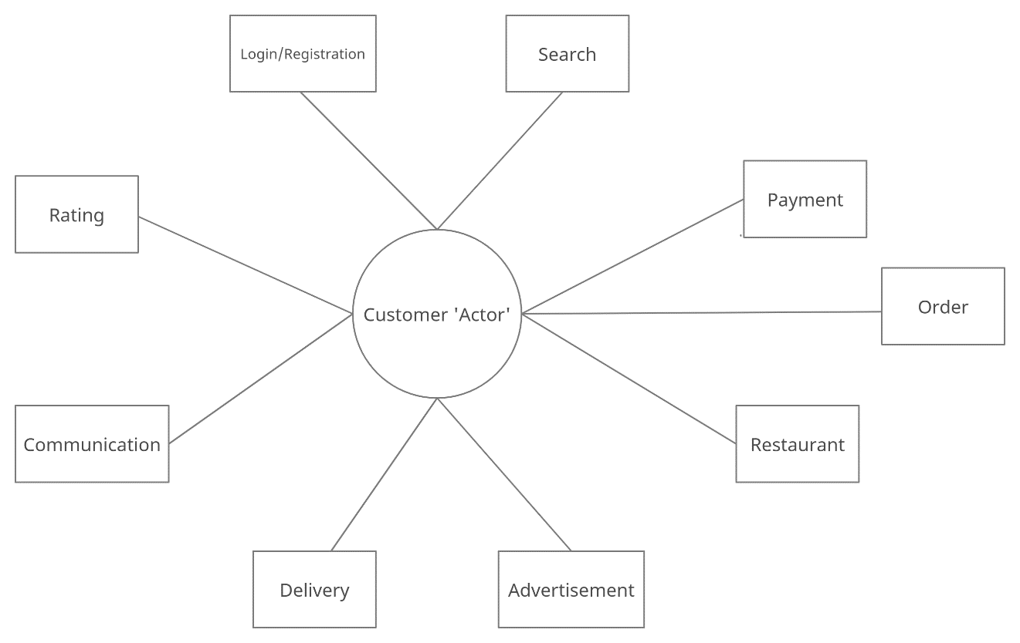

# 4. Systems Requirements

## 4.1 “Registration And Login” Requirements

|  |  |
| --- | --- |
| **Requirement Title:** | Login and Registration |
| **Sequence No:** | 001 |
| **Short description:** | Register new user |
| **Description:** | New users must register before accessing the application. The following information will be collected:   * Name {First, Last name} * Email address * Phone number * Select an ID {at least 8 character long, alphanumeric, wild characters not allowed} * Select a password {Must include, letters, at least one number, at least Capital letter, wild characters allowed) * Select a security question/answer (to be Used for password forgot/reset)   User can press:   * Submit * Cancel (i.e., discard changes) * Exit screen (or close) |
| **Pre-Conditions**: | * Application must be loaded already * Duplicate registration is not allowed |
| **Post Conditions:** | * All “Saved” changes will be kept permanently |
| **Other attributes:** | * None |

|  |  |
| --- | --- |
| **Requirement Title:** | Login and Registration |
| **Sequence No:** | 002 |
| **Short description:** | Login Existing User |
| **Description:** | Enter User Id and Password (already established during Registration) and Press Submit  User can press:   * Submit * Forgot ID or Password * Cancel (i.e., discard changes) * Exit screen (or close) |
| **Pre-Conditions**: | * User must have already registered |
| **Post Conditions:** | * Keep a log of the date and time of login |
| **Other attributes:** | * Allow a maximum of three tries, then recommend using “Forgot Password” |

|  |  |
| --- | --- |
| **Requirement Title:** | Login and Registration |
| **Sequence No:** | 003 |
| **Short description:** | Forgot Password |
| **Description:** | Ask user for the Answer to the “Security Question” entered during the “Registration” phase, i.e. see 001 above. Also ask for e-mail address. If both e-mail and security answer is correct, reset the password and e-mail the temporary password via e-mail  User can press:   * Submit * Cancel (i.e., discard changes) * Exit screen (or close) |
| **Pre-Conditions**: | * User must have already registered * Validate e-mail and security question |
| **Post Conditions:** | * Recommend use to change their temporary password after accessing the system |
| **Other attributes:** | * Lock system after 3 tries * Consider adding more than one security question |

## 4.2 “Search” Requirements

|  |  |
| --- | --- |
| **Requirement Title:** | Search |
| **Sequence No:** | 001 |
| **Short description:** | Search any data available to users |
| **Description:** | Application will have search functionality. Users will be able to search for any restaurants or food items. Search functionality will be able to utilize Google search.   * User will type the name of the restaurant or food item in the search box * Search suggestions will be based on recent queries * If input matches suggestions, search results will be displayed * If input doesn’t match the data, then results error message is shown * User can search unlimited times   User can press:   * Search button * Cancel (i.e., discard changes) |
| **Pre-Conditions**: | Application must be loaded already  Search button  A search dialog that appears at the top of the screen when search button is clicked |
| **Post Conditions:** | Providing valid input in search leads to search results  Providing invalid input in search displays error message |
| **Other attributes:** | None |

## 4.3 “Payments” Requirements

|  |  |
| --- | --- |
| **Requirement Title:** | Payment |
| **Sequence No:** | 001 |
| **Short description:** | User decides on how to pay between meal plan or card. |
| **Description:** | Display meal plan or credit card for payment method. If user press payment plan it will prompt the customer to enter student ID. If the customer press ‘credit card’ he or she must enter 16-digit card number, expiration date, and 3-digit security code.  In addition, if the customer changes their mind, after seeing price they can add to cart or take off cart.  User can press:   * Add more to cart Button * Take off Button * Type 3-digit security code Button * Enter student ID * Enter 16-digit card number * Enter expiration date * Place order button * Track order |
| **Pre-Conditions**: | User have already shopped for their items and wants to make a payment to place order |
| **Post Conditions:** | Ask the user do you want to track your  If no:  Show customer receipt and order number.  If yes:  Direct customer to Delivery page |
| **Other attributes:** | After the Customer is finished Paying, notification “Thank you for shopping is” is popped up |

## 4.4 “Orders” Requirements

|  |  |
| --- | --- |
| **Requirement Title:** | Orders |
| **Sequence No:** | 001 |
| **Short description:** | User selects their choice.  Add/Remove the items to/from cart |
| **Description:** | Display a list of categories at the selected restaurant, such as Beverages, Breakfast, Combo Meals, Desserts, …  User can see the images of the food that is currently served at the restaurant, and add them to their cart  User can view their cart and remove an item if the item is not their choice, or cancel their order  In addition, if the user views their cart, display the total cost of the selected items  User can press:   * Menu Button * Add to Cart Button * Remove from Cart Button * Checkout Button * Cancel Button |
| **Pre-Conditions**: | User have already logged in  User must select a specific restaurant |
| **Post Conditions:** | Ask the user do you want to continue shopping  If no:  navigate user to proceed to checkout  If yes:  remain in the same food displaying screen |
| **Other attributes:** | After selection, notification “Item added to your cart” is popped up |

## 4.5 “Restaurants” Requirements

|  |  |
| --- | --- |
| **Requirement Title:** | Restaurant |
| **Sequence No:** | 001 |
| **Short description:** | Restaurant Account  Each restaurant will have a restaurant account |
| **Description:** | A restaurant class contains the following information:   * Name * Location * Cuisine * Hours * A Menu * Current backup time   A restaurant will be able to conduct or respond to the following actions:   * View menu: Show a customer a menu in app * Place an order: A customer can submit an order to a restaurant at which point the restaurant will need to accept the order and mark the order completed when it is done * Check hours: The app will be able to send an hour check to the restaurant * Temporarily close: The restaurant can temporarily close * Change hours: A restaurant can change hours freely * Edit restaurant: A restaurant can submit a change to the restaurant’s name, address, location, or cuisine to the administrators * Edit menu: the restaurant account has access to edit all aspects of its menu |
| **Pre-Conditions**: | A restaurant is created by admins via the restaurants list |
| **Post Conditions:** | None |
| **Other attributes:** | None |

|  |  |
| --- | --- |
| **Requirement Title:** | Restaurant |
| **Sequence No:** | 002 |
| **Short description:** | Restaurant List-  All restaurant accounts are managed by the restaurant list |
| **Description:** | The restaurant list contains the following information:   * List of restaurants   A restaurant will be able to conduct or respond to the following actions:   * Add restaurant: The restaurant list can add a restaurant providing all restaurant information. Two restaurants should not have the same location and name. * Delete restaurant: The restaurant list can remove restaurants * Edit restaurant- the restaurant list can change any restaurant information |
| **Pre-Conditions**: | * The restaurant list can be empty but always exists in the system |
| **Post Conditions:** | None |
| **Other attributes:** | None |

|  |  |
| --- | --- |
| **Requirement Title:** | Restaurant |
| **Sequence No:** | 003 |
| **Short description:** | Menu  Each restaurant account contains a menu |
| **Description:** | The restaurant list contains the following information:   * List of Items   A Menu will be able to conduct or respond to the following actions:   * Add item: The restaurant can call to add an item * Delete item: The restaurant can call to delete an item * Edit item: The menu can be called to edit any menu items info * View: view menu |
| **Pre-Conditions**: | None |
| **Post Conditions:** | None |
| **Other attributes:** | None |

## 4.6 “Advertisement” Requirements

|  |  |
| --- | --- |
| **Requirement Title:** | Advertisement |
| **Sequence No:** | 001 |
| **Short description:** | Advertisement  Advertisements linked to restaurants present in the app which will be displayed on user’s home page and link to the restaurant page |
| **Description:** | An advertisement contains the following information:   * Image file * Text * Font * Background color * Restaurant   An Advertisement responds to a display request |
| **Pre-Conditions**: | None |
| **Post Conditions:** | None |
| **Other attributes:** | None |

## 4.7 “Delivery” Requirements

|  |  |
| --- | --- |
| **Requirement Title:** | Delivery |
| **Sequence No:** | 001 |
| **Short description:** | Show delivery process |
| **Description:** | Display options to see if the user wants their items to be delivered  If yes, notify the restaurant to find a driver, display message: “Finding your driver”  If found, send the user the driver’s information  Calculated the estimated time before the driver reaches the destination  If the user decided to pick up, calculated preparing time, then notify user to pick up if finished  User can press:   * Delivery Button * Pick Up Button |
| **Pre-Conditions**: | The user must log in to the application  The user must already make the order and pay for the items |
| **Post Conditions:** | None |
| **Other attributes:** | Send the user message: “Thank you for using delivered service” if the user request for delivery |

## 4.8 “Communication” Requirements

|  |  |
| --- | --- |
| **Requirement Title:** | Communication |
| **Sequence No:** | 001 |
| **Short description:** | Get order updates |
| **Description:** | System should allow for sending text message/e-mails to a single, subgroup or all users. Users will get updates on their orders once they confirm their order. Updates will show:   * If order has successfully placed * Delivery Status * Estimated time of arrival * If order had been picked up * If order has been delivered   User can press:   * Yes * Cancel |
| **Pre-Conditions**: | Application must be loaded already  Order must be confirmed |
| **Post Conditions:** | All updates’ records will be saved |
| **Other attributes:** | None |

## 4.9 “Rating” Requirements

|  |  |
| --- | --- |
| **Requirement Title:** | Ratings |
| **Sequence No:** | 001 |
| **Short description:** | Ratings  Customers are given the option to rate previously placed orders |
| **Description:** | The customer will give the following info in a rating:   * Rating out of 5 * If a rating over 4 is given what was positive is asked answer is optional * If rating was under 4 what was negative is asked answer is non-optional   Allow user to type into the feedback blank space  User can press:   * Submit Feedback Button |
| **Pre-Conditions**: | Order has been previously placed and completed but has not yet been reviewed |
| **Post Conditions:** | Order updated to rated, ratings are sent to review |
| **Other attributes:** | None |

|  |  |
| --- | --- |
| **Requirement Title:** | Ratings |
| **Sequence No:** | 002 |
| **Short description:** | Rating list  Each restaurant contains two ratings lists a reviewed and non-reviewed list |
| **Description:** | The rating list contains the following attributes:   * average rating * ratings   The ratings respond to the following:   * add_rating() function * delete_rating() function |
| **Pre-Conditions**: | None |
| **Post Conditions:** | None |
| **Other attributes:** | None |

# 5. Software Processes and Infrastructure

## 5.1 Hardware and Infrastructure

The University Food System Project will be implemented using Android version KitKat

## 5.2 UML Diagrams

**UML – Class Diagram – University Food System**

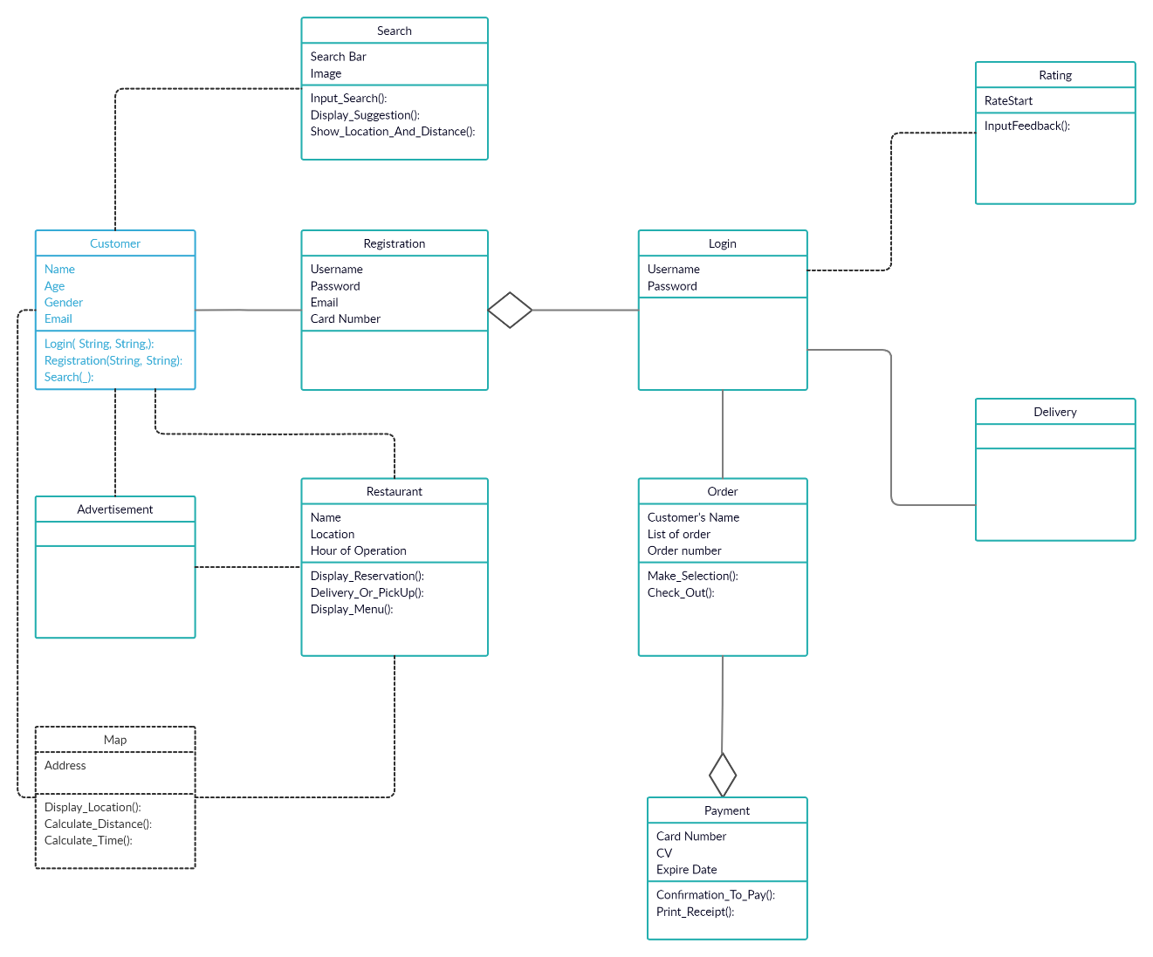

**UML – State Transition Diagram – Login and Registration (Part 1)**

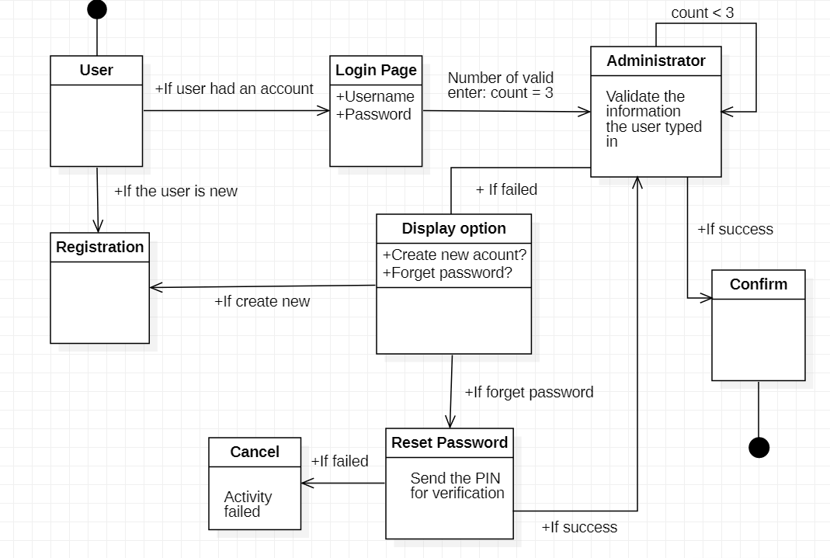

**UML – State Transition Diagram – Login and Registration (Part 2)**

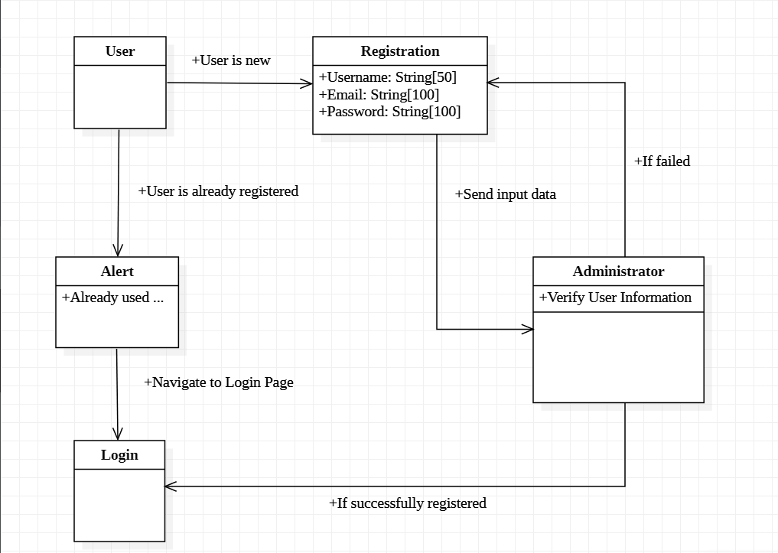

**UML – Activity Diagram – Search**

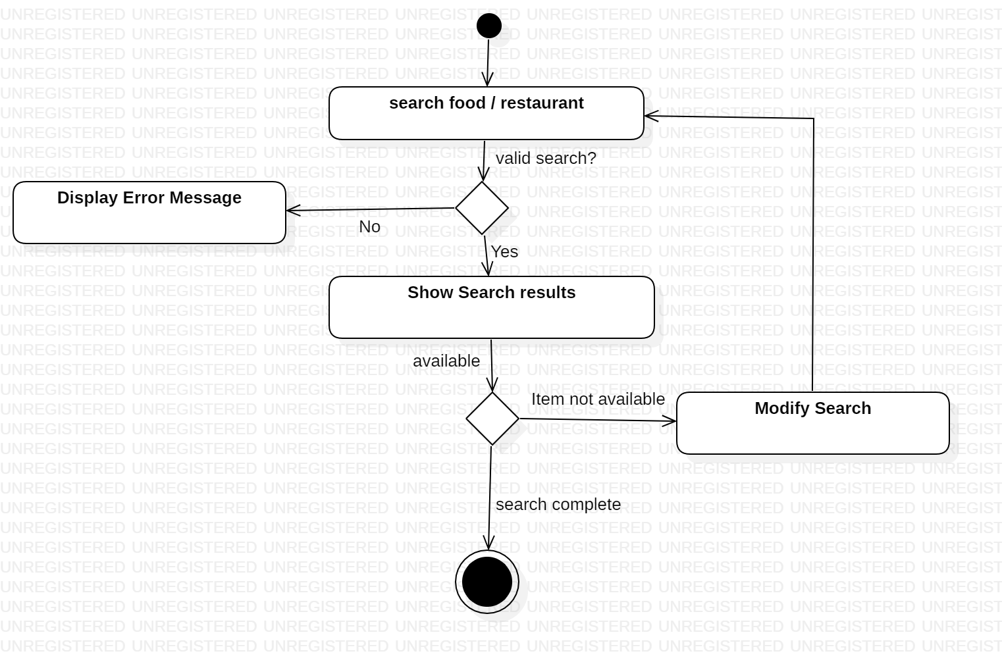

**UML –Class Diagram – Restaurant and Advertisement**

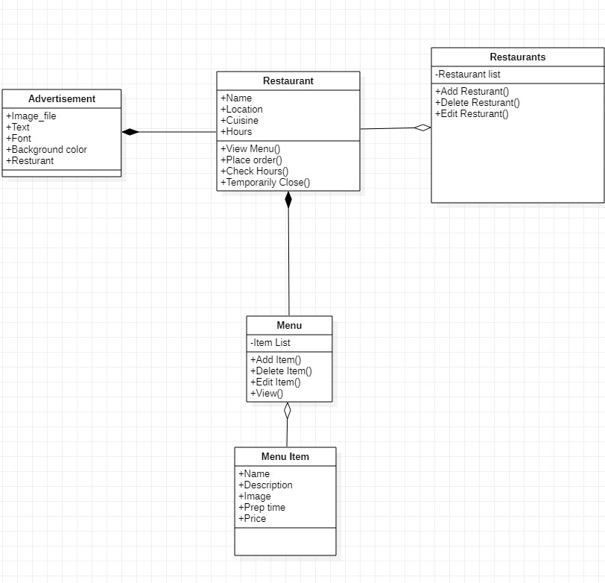

**UML – State Transition Diagram – Order**

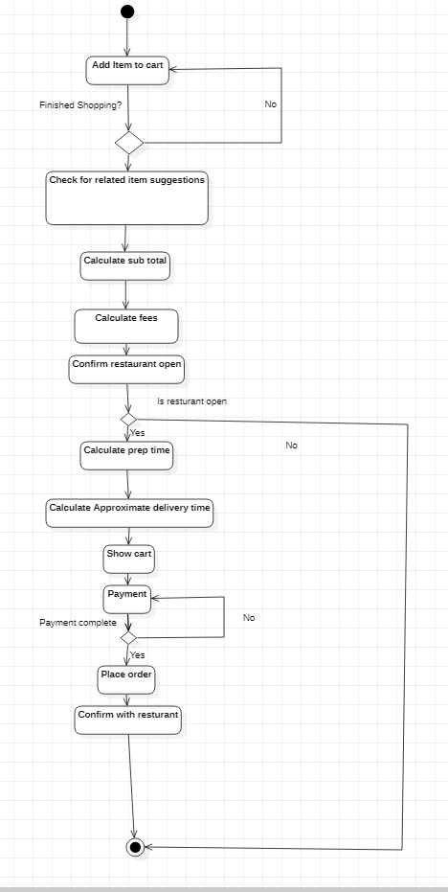

**UML – State Transition Diagram – Ratings**

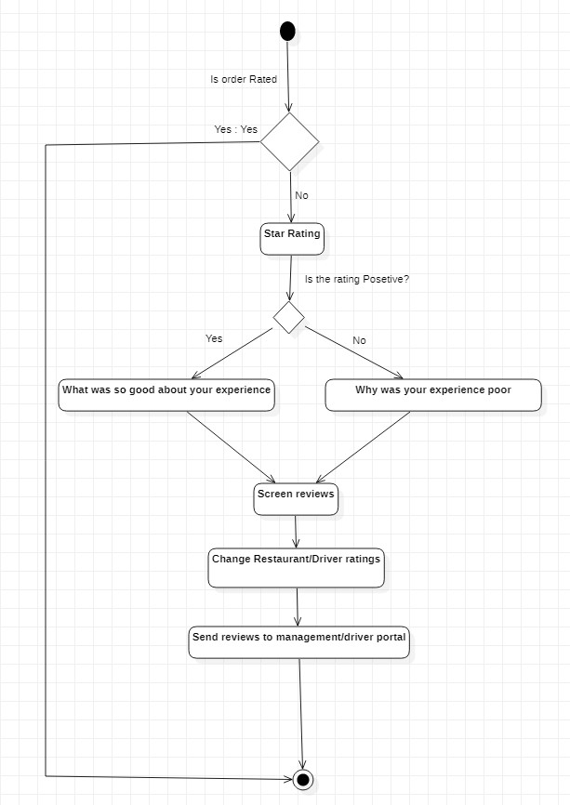

**UML – Activity Diagram – Communication**

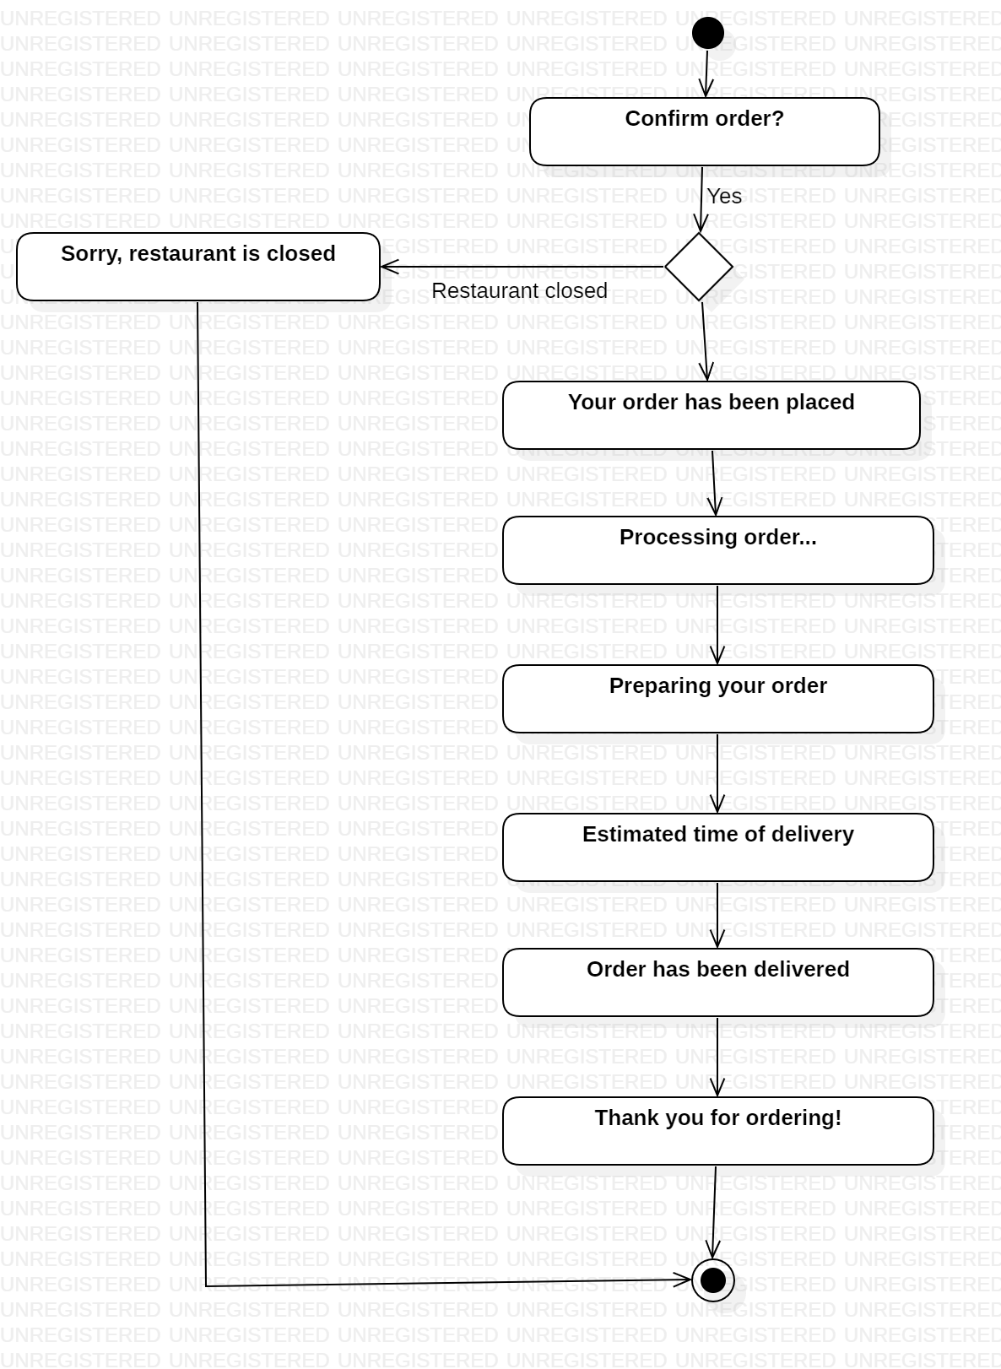

**UML – State Transition Diagram – Payment**

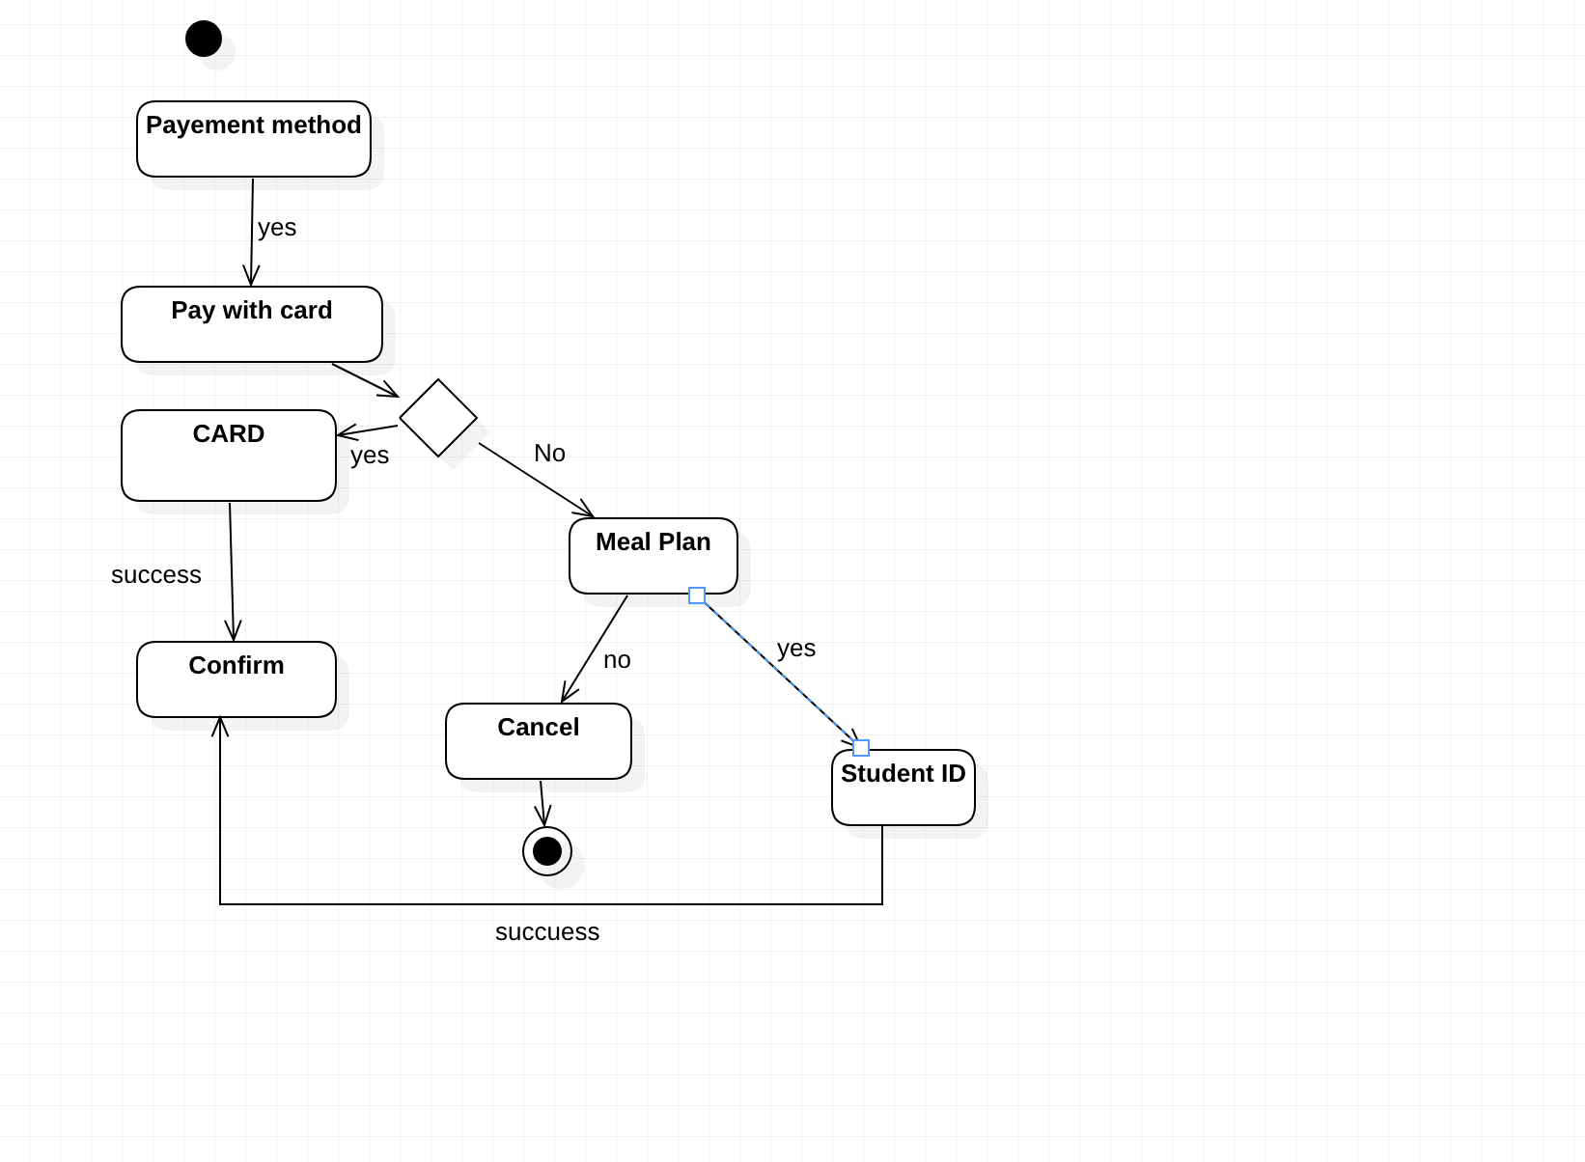

**UML – State Transition Diagram – Delivery**

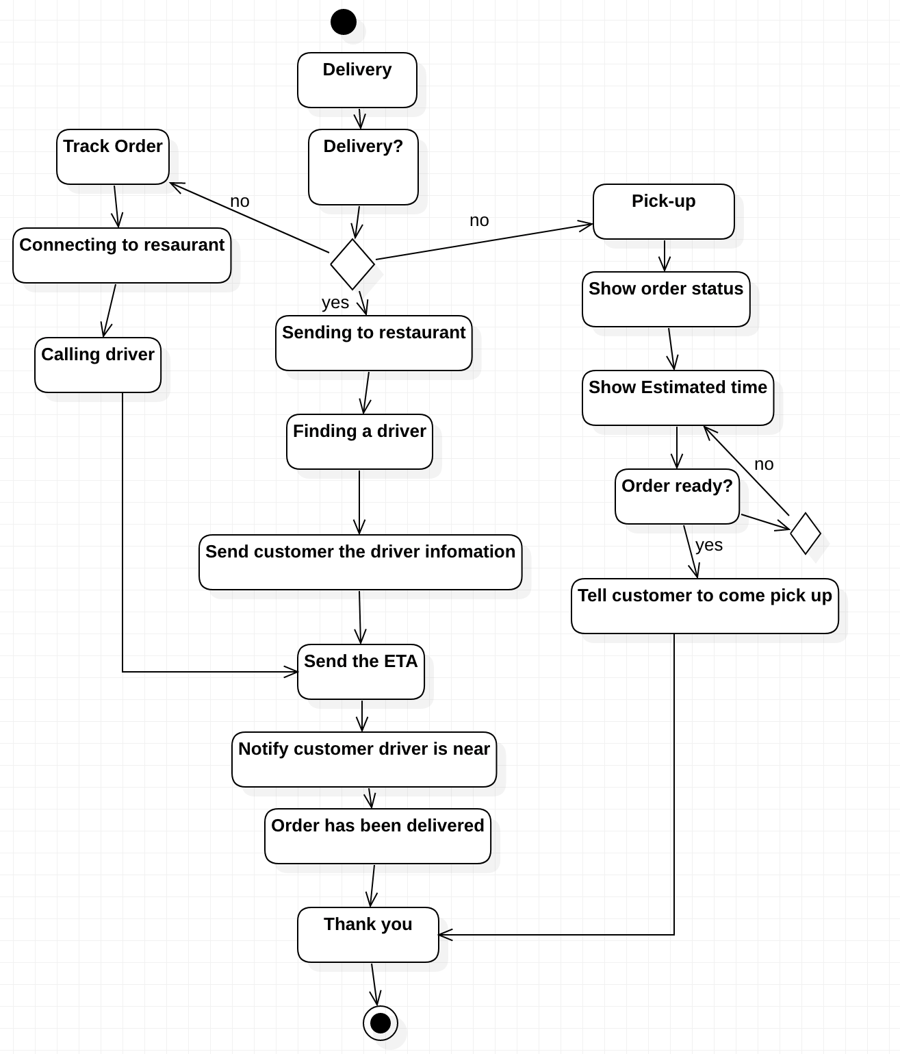

## 5.3 Screen Shots

There are no screen shots available currently

## 

## 5.4 Test Plan

The test plan will be provided at the later stage of the project

# 6. Assumptions and Constraints

## 6.1 ASSUMPTIONS

The following is a list of assumptions:

* Ignore validating credit card numbers initially
* Ignore compliance issues
* Assume the user is already a student on campus to access the system
* The restaurants displayed in the drop-down menu are all located within university area
* Meal exchanges using in payment can be applied to all restaurants within any time

## 6.2 CONSTRAINTS

The following is a list of constraints:

* Team lacks android experience
* Schedule very aggressive
* Team does not have experiencing in implementing database and use search tool before
* Team lack experience in designing interface

## 6.3 Out of Scope material

The following is a list of “out of scope” material:

* Post Project maintenance is not covered
* Creating a map displaying the location of the customer and the restaurants is not part of the first delivery phase

# 7. Delivery and Schedule

|  |  |  |  |  |
| --- | --- | --- | --- | --- |
| Task/Milestone Description | Anticipated Start Date | Anticipated End Date | Status | Comments |
| Prepare Requirements and UML diagram | 9/14/2021 | 9/30/2021 | Complete | Deliverable UML document. Increment 1 Deliverable |
| SRA document (Includes project objectives, Requirements and UML diagrams) | 10/5/2021 | 10/28/2021 | In Progress | Deliverable will be the SRA document. All stakeholders agree on the content of the SRA by signing in section 8.  Increment 2 Deliverable |
| Home screen design and implementation | 10/18/2021 | 10/20/2021 | In Progress | Gia Dao |
| Login and registration design and implementation | 10/28/2021 | 11/9/2021 | In Progress | Sumaita Sabaha |
| Search implementation | 10/28/2021 | 11/9/2021 | To Be Completed (TBC) | Sumaita Sabaha |
| Payment Implementation | 11/9/2021 | 11/16/2021 | To Be Completed (TBC) | Ja’Lun Morris |
| Order Implementation | 11/9/2021 | 11/16/2021 | To Be Completed (TBC) | Gia Dao |
| Restaurant Implementation | 11/16/2021 | 11/23/2021 | To Be Completed (TBC) | Cameron Chilcoat |
| Advertisement Implementation | 11/16/2021 | 11/23/2021 | To Be Completed (TBC) | Cameron Chilcoat |
| Delivery Implementation | 11/16/2021 | 11/23/2021 | To Be Completed (TBC) | Ja’Lun Morris |
| Communication Implementation | 11/16/2021 | 11/23/2021 | To Be Completed (TBC) | Gia Dao and Sumaita Sabaha |
| Rating Implementation | 11/16/2021 | 11/23/2021 | To Be Completed (TBC) | Cameron Chilcoat |
| Test case design | 10/29/2021 | 11/18/2021 | To Be Completed (TBC) | Increment 3 Deliverable |
| External Documentation (i.e., User Manual) | 12/5/2021 | 12/7/2021 | To Be Completed (TBC) | Team |
| Project presentation | 11/30/2021 | 12/7/2021 | To Be Completed (TBC) | Team |
| Final Milestone: project delivery |  | 12/7/2021 | To Be Completed (TBC) | Increment 4 Deliverable |

# 8. Stakeholder Approval Form

|  |  |  |  |
| --- | --- | --- | --- |
| Stakeholder Name | Stakeholder Role | Stakeholder Comments | Stakeholder Approval Signature and Date |
| Bahram Khalili | Development Mgr |  |  |
| Akshit Singhal | Project Assistant |  |  |
| Cameron Chilcoat | Developer |  | C.C.  10/27/2021 |
| Ja’Lun Morris | Developer |  | J.M  10/27/2021 |
| Sumaita Sabaha | Developer |  | S.S  10/27/2021 |
| Gia Dao | Developer |  | G.D  10/25/2021 |

# Appendix:

None